**FOREIGN TRADING SYSTEM**

**USE CASE DIAGRAM:**

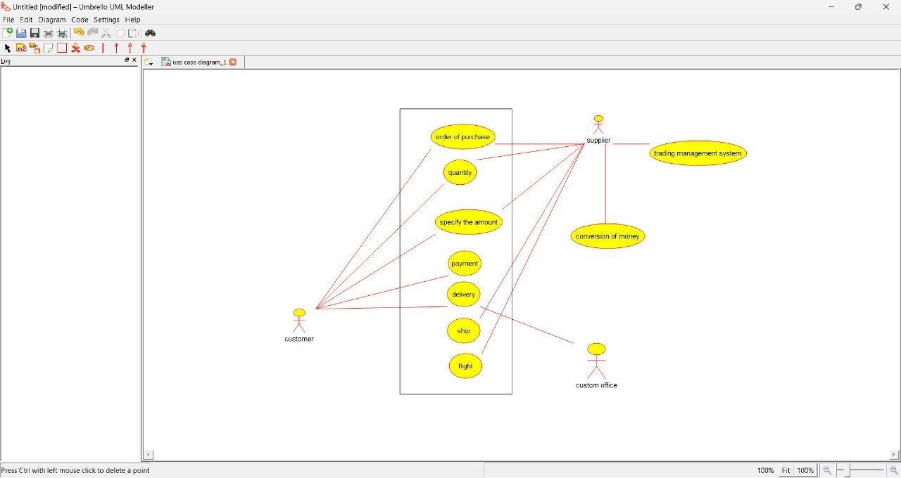

**CLASS DIAGRAM:**

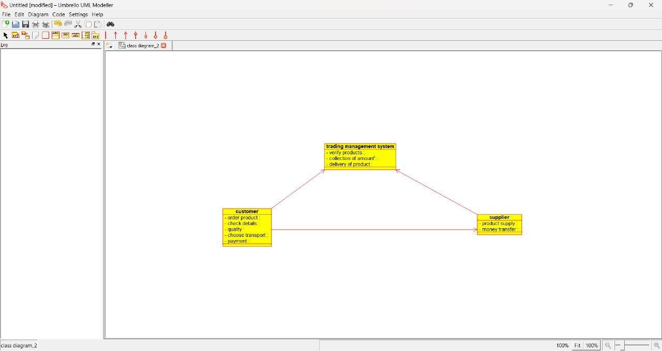

**ACTIVITY DIAGRAM:**

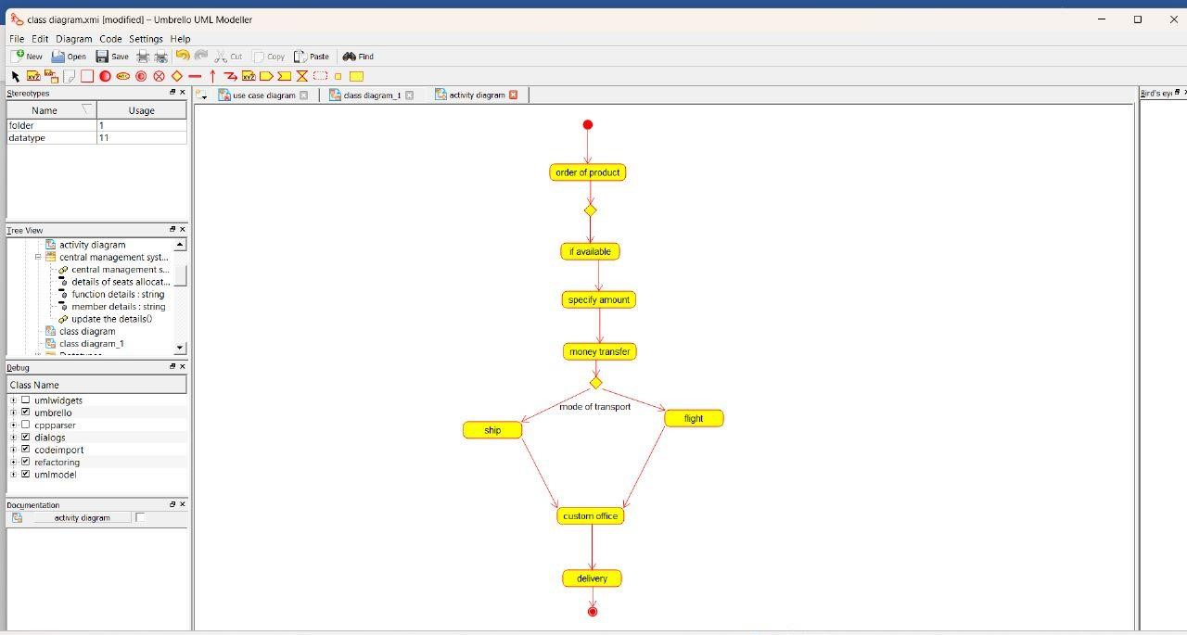

**SEQUENCE DIAGRAM:**

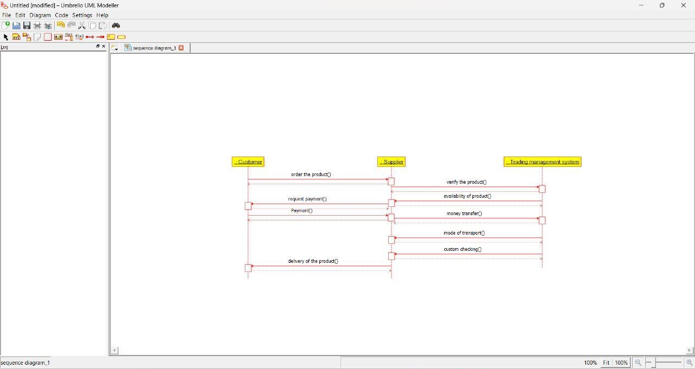

**COLLABORATION DIAGRAM:**

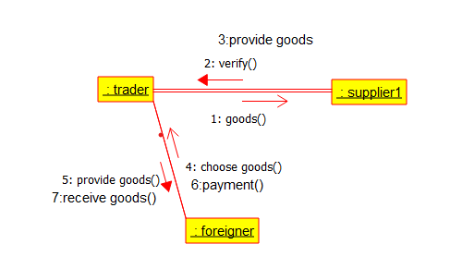

**COMPONENT DIAGRAM:**

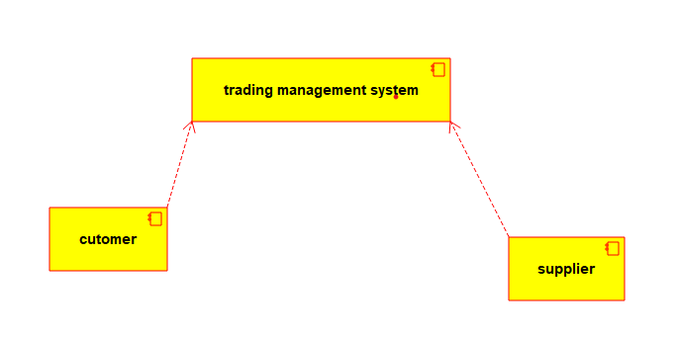

**DEPLOYMENT DIAGRAM:**

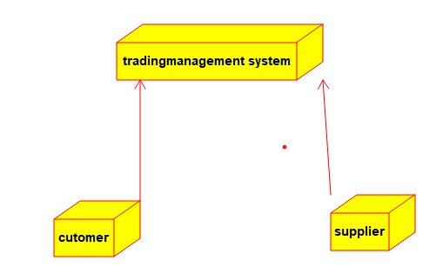

**PROGRAM:**

/**

* Class customer

*/

public class customer {

//

// Fields

//

private void order_product;

private void quality;

//

// Constructors

//

public customer () { };

//

// Methods

//

//

// Accessor methods

//

/**

* Set the value of order_product

* @param newVar the new value of order_product

*/

public void setOrder_product (void newVar) {

order_product = newVar;

}

/**

* Get the value of order_product

* @return the value of order_product

*/

public void getOrder_product () {

return order_product;

}

/**

* Set the value of quality

* @param newVar the new value of quality

*/

public void setQuality (void newVar) {

quality = newVar;

}

/**

* Get the value of quality

* @return the value of quality

*/

public void getQuality () {

return quality;

}

//

// Other methods

//

}

/**

* Class supplier

*/

public class supplier {

//

// Fields

//

private void product_supply;

//

// Constructors

//

public supplier () { };

//

// Methods

//

//

// Accessor methods

//

/**

* Set the value of product_supply

* @param newVar the new value of product_supply

*/

public void setProduct_supply (void newVar) {

product_supply = newVar;

}

/**

* Get the value of product_supply

* @return the value of product_supply

*/

public void getProduct_supply () {

return product_supply;

}

//

// Other methods

//

}